uOMUNA Executive Meeting No. #
Date: Sunday August 17th, 2025 | Time: 4:00pm | Place: Virtual (MS Teams)
- Call to Order (2 min.)
  - The executive committee meeting is called to order at 4:13pm. Cameron Cadogan is serving as the Chair for the meeting in the role of President. Stephanie Magistrado is serving as clerk in their role as VP Administration.

- Land Acknowledgement (2 min.)
We pay respect to the Algonquin and Anishinaabe people, who are the traditional guardians of this land. We acknowledge their long-standing relationship with this territory, which remains unceded. We pay respect to all Indigenous people in this region, from all nations across Canada, who call Ottawa home. We acknowledge the traditional knowledge keepers, both young and old. And we honour their courageous leaders: past, present, and future.
Let us not forget that Canada was one of only four countries that voted against the adoption of The United Nations Declaration of the Rights of Indigenous Peoples. As members of the of uOMUNA we are presented with a unique and important role to play within our commitment to promoting diplomatic values and creating progressive change. It must go hand in hand with practices of Decolonization and Reconciliation. We are surrounded by the people who represent the future of politics and the work necessary to better the relationship between Indigenous people of Canada and our society.
We make this acknowledgement of the Algonquin, Anishinaabe and all Indigenous people of Canada as well as the lands as a reminder of our responsibility and obligations to ensure our work here never fails to lift up and support all Indigenous thinkers, leaders, and peoples alike.

- Necessary Interferences (2 min.)

- Attendance
Name | Position
Cameron Cadogan | President | Present
Joy Wang | VP Finance | A`
Stephanie Magistrado | VP Administration | Present
Ezra Pristolic | VP Delegate Coordination | a
Glory Jean Ntambwe | VP Media | Present
Mirko Onufrak | VP Training | Present
Christopher Hourany | VP Training | a
Camélia Elaoufi | VP Engagement | a
Olivia Grado | Secretary General (CAPMUN) | a
Yvanessa Veillard | Interim VP of Francophone Affairs | a
Emma Marleau | Director of Training Support | a
Xavier Johnson | Director of Special Projects | a
Sydney Ho | Director of External Affairs | Present
AGENDA:
- September planning/recruitment
  - Cameron: September is a big month for recruitment, so we have many opportunities for recruitment. A few goals I have for September: have at least 50 paid members for the club by the end of the month, alot of that can be done at tabling. Camelia will plan a social that will probably be in a park. I am also hoping for an in house that is beginner focused at the end of the September. Also hoping we can do info sessions (at least 2), only thing is that we have used classrooms for those before, but I dont wanna talk away from the classrooms cuz poor
- Tabling
  - Cameron: We have the UOSU Club fair, in the Grand ALLEY which is where you walk down between UCU, 90U, to FSS at Thursday Sept 4th, 12pm-2pm, wondering if IPPSSA will follow up.
  - Steph: can I make a new board?
  - Cameron: Yes
  - Cameron: The banner, I need to figure out where it is, a past exec has it and I will get it back when I get back to ottawa. If you don't have time to go to tabling, you can just drop on.
  - Sydney: I think we should make an FAQ sheet
  - Cameron: ya.
  - Sydney: who will make it
  - Cameron: me
  - Sydney: let us know if you need support for that
  - Cameron: any questions
  - Sydney: In terms of schedule, is there a specific number we want?
  - Cameron: I want at least 3 people, but there are times we have had 7 or 8 people
- Moneyyy
  - Cameron: We have many membership fees, 2383.13 is our current balance, we’ve got an increase about 200 dollars in membership fees, Sydney I will talk to you about raising funds
  - Sydney: The sooner the better
  - Steph: So far I collected $125 fees in cashbox
  - Cameron: our financial position is satisfactory so far
- 1 on 1s
  - Cameron: I will have 1on1 meetings again, these are good because its good to have conversation with people.
- Forms and Membership fees
  - Cameron: There are two forms, these are for the pins and the capcut pro membership so we need to finish voting on it. For membership, the fees are important for the club, its a source of income, everyone should pay the membership fee, so please do so soon. I want at least 100 paid members this year and I think this is totally possible.
- Stickers
- Steph: I want to advocate for buying either 100 or 200 labels. Label sheets are cheaper than sticker, we can cut them ourselves and give them out during our event as collateral for promotion. Sticker Mule was recommended to me, prices provided below. I think this design with our logo and our IG handle is good.
- Cameron: second design is better
- Steph: Ill mock up designs, but if we can vote on buying stickers would be great
- 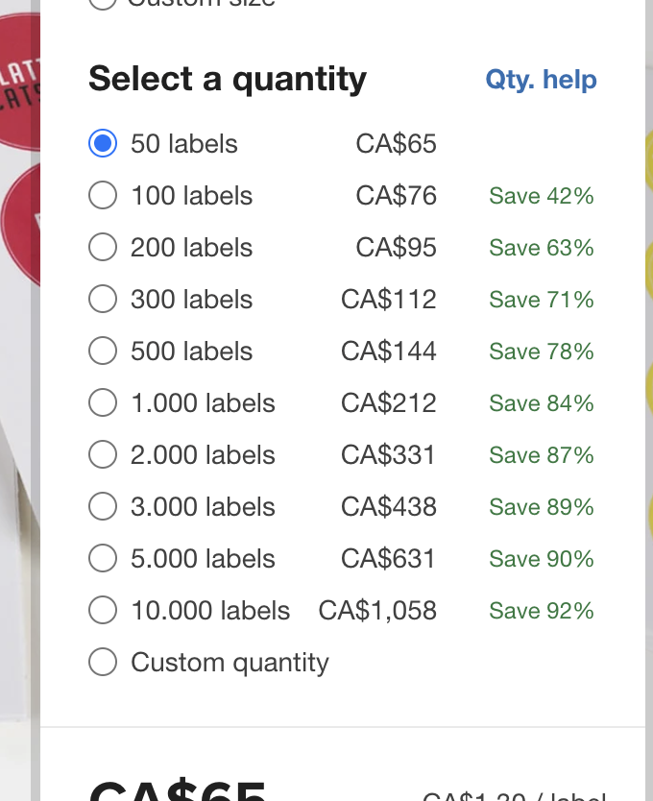

]

- Misc
- Sydney: I'm curious about the merch from last year and we should still be getting them and i think we should have merch to sell to fund which would be good, wondering if any update on that.
Cameron: I need to reach out to them, But I've seen the email chain
Cameron: I'll reach out, and we can ask for UOSU’s advice in case.

Meeting adjourned at 4:42pm

